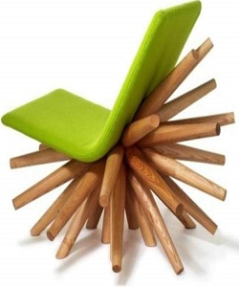

Modern burst Chair

$39.21

Availability: In stock

Description

Modern green burst chair with many wood sticks. Standard Finish in brown wood Available, for all sitting purpose color are available. This will décor your home with a way it make your living room, lounge center of attraction, it’s unique design is the part of modern furniture.